7 – sinf III-chorak ChSB
1 variant
1. (B-1) Quyidagi mulohazalar to‘g‘ri yoki noto‘g‘ri ekanini aniqlang.
Mulohaza | To‘g‘ri | Noto‘g‘ri
$(-2; 2)$ nuqta $y=\frac{1}{4}x^{3}$ funksiya grafigiga tegishli
Agar $y=ax^{2}$ funksiyada $a<0$ bo ‘lsa, bu funksiya grafigi III va IV choraklarda yotadi
$y=ax^{2}$ funksiyaning grafigi parabola bo‘ladi
A) to‘g‘ri, to‘g‘ri, noto‘g‘ri B) to‘g‘ri, to‘g‘ri, to‘g‘ri
C) noto‘g‘ri, to‘g‘ri, to‘g‘ri D) noto‘g‘ri, to‘g‘ri, noto‘g‘ri
2. (Q-4) Berilgan funksiyalarning assimptotalarini topib, mos keltiring.
1. $y=\frac{2}{5x-7}+14$ | A. $x=1,4$ va $y=-14$
2. $y=\frac{-7}{5x-7}-14$ | B. $x=1,4$ va $y=14$
 | C. $x=-1,4$ va $y=14$
 | D. $x=-1,4$ va $y=-14$
A) 1-B, 2-D B) 1-D, 2-B C) 1-A, 2-B D) 1-B, 2-A
3. (B-1) $y=|5-2x|$ funksiyaning qiymatlar to‘plamini toping.
A) $[0;+∞)$ B) $[\frac{2}{5};+∞)$ C) $[2,5; ∞)$ D) $(0;∞)$
4. (B-1) Uchburchakning perimetri 49 cm. Uning birinchi tomoni ikkinchisidan 1 cm uzun, ammo uchinchisidan 2 cm qisqa. Shu uchburchak kichik tomoni uzunligini (cm) toping.
A) 16 B) 15 C) 18 D) 14
5. (Q-4) Tenglamani butun sonlarda yeching: $3x+2y=25$
A) $\left\{\begin{matrix}x=1+3t \\ y=11-2t\end{matrix} t∈Z\right.$ B) $\left\{\begin{matrix}x=1+2t \\ y=11+3t\end{matrix} t∈Z\right.$
C) $\left\{\begin{matrix}x=1-2t \\ y=11-3t\end{matrix} t∈Z\right.$ D) $\left\{\begin{matrix}x=1+2t \\ y=11-3t\end{matrix} t∈Z\right.$
6. (Q-4) Tenglamalar sistemasini yeching: $\left\{\begin{matrix}6x-5y=16 \\ 7x+3y=1\end{matrix}\right.$
A) $(1;-2)$ B) $(1;2)$ C) $(-1;2)$ D) $(-1;-2)$
7. (Q-4) Tenglamalar sistemasini yechimlarining ko‘paytmasini toping: $\left\{\begin{matrix}\frac{3}{x}+\frac{8}{y}=2,5 \\ \frac{7}{x}-\frac{2}{y}=\frac{2}{3}\end{matrix}\right.$
A) $-24$ B) $12$ C) $24$ D) $10$
8. (Q-4) Determinantni hisoblang: $\left|\begin{matrix}4 & 9 & 14 \\ 5 & 15 & 24 \\ 0 & 24 & 38\end{matrix}\right|$
A) $-5$ B) $769$ C) $-54$ D) $5$
9. (Q-4) Hovuzga uchta quvur o‘tkazilgan. Birinchi va ikkinchi quvurlar hovuzni 1 soat-u 10 daqiqada; birinchi va uchinchi quvurlar 1 soat-u 24 daqiqada; ikkinchi va uchinchi quvurlar esa 2 soat-u 20 daqiqada to‘ldiradi. Uchala quvur bir vaqtda ochib qo‘yilsa, hovuz qancha vaqtda to‘ladi?
A) 30 daqiqada B) 1 soatda C) 45 daqiqada D) 50 daqiqada
10. (M-5) Ikki idishda suyuqlik bor. Birinchi idishdan ikkinchisiga ikkinchi idishdagi suyuqlikdan 2 baravar ko‘p suyuqlik quyildi. So‘ngra birinchi idishga, unda qolgan suyuqlikning yarmi qadar suyuqlik ikkinchi idishdan quyildi. Natijada har qaysi idishdagi suyuqlik 36 litrdan bo‘ldi. Dastlab har qaysi idishda qanchadan suyuqlik bo‘lgan?
A) 1-idishda 56 l, 2-idishda 16 l B) 1-idishda 16 l, 2-idishda 56 l
C) 1-idishda 180 l, 2-idishda 30 l D) 1-idishda 30 l, 2-idishda 180 l
11. (Q-1,5) Parametr $a$ ning $3x+2ay=3$ va $3(a-1)x-ay=1$ to‘g‘ri chiziqlar umumiy nuqtaga ega bo‘lmaydigan barcha qiymatlarini toping.
A) $a≠2$ B) $a≠\frac{1}{2}$ C) $a=\frac{1}{2}$ D) $a≠-2$
12. (Q-4) $A=\{1, 5, 9, 3, 2\}$ va $B=\{1, 2, 5, 6, 7\}$ bo‘lsa, $A∪B$ to‘plamning qism to‘plamlari sonini toping.
A) 129 B) 127 C) 126 D) 128
13. (B-4) Ikkita parallel to‘g‘ri chiziqni kesuvchi kesib o‘tganda hosil bo‘lgan burchaklarning yettitasi yig‘indisi ${580}^{0}$ ga teng bo‘lsa, kichik burchak qiymatini toping.
A) ${40}^{0}$ B) ${60}^{0}$ C) ${70}^{0}$ D) ${65}^{0}$
14. (Q-5,2) Ikki parallel to‘g‘ri chiziqni uchinchi to‘g‘ri chiziq kesib o‘tganda, hosil bo‘lgan ichki bir tomonli burchaklardan biri ikkinchisidan $60^{0}$ ga kichik. Shu burchaklardan kattasini toping.
A) $130°$ B) $120°$ C) $140°$ D) $110°$
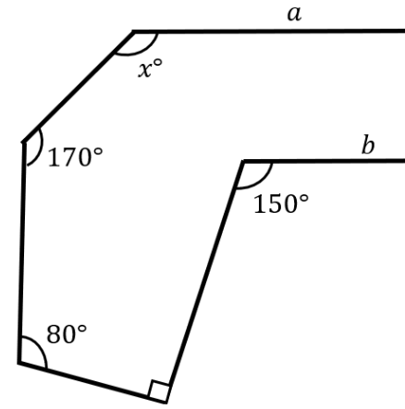
15. (M-6) Rasmda berilgan ma’lumotlardan foydalanib, agar $a||b$ bo‘lsa, noma’lum $x$ ning qiymatini toping.
A) 160$°$
B) 170$°$
C) 100$°$
D) 150$°$

16. (B-4) Uchburchakning ichki burchaklarining biri ikkinchisidan 2 marta katta, uchinchisidan esa 3 marta kichik bo‘lsa, shu burchaklardan kattasini toping.
A) $135°$ B) $90°$ C) $100°$ D) $120°$
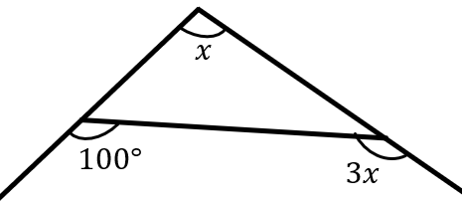
17. (Q-5,2) Rasmda berilgan ma’lumotlardan foydalanib, noma’lum $x$ ning qiymatini toping.
A) $14°$
B) $45°$
C) $40°$
D) $30°$
18. (Q-5,2) To‘g‘ri burchakli uchburchakning to‘g‘ri burchagidan bissektrisa va balandlik chiqarilgan bo‘lib, ular orasidagi burchak 20° ga teng. Uchburchakning gipotenuzaga yopishgan burchaklardan kattasini toping.
A) $50°$ B) $75°$ C) $60°$ D) $65°$
19. (Q-5,2) $-12x+5y-6=0$ va $-3x+1,25y+7=0$ to‘g‘ri chiziqlar orasidagi masofani toping.
A) $\frac{24}{13}$ B) $\frac{34}{13}$ C) $\frac{22}{13}$ D) 1,8
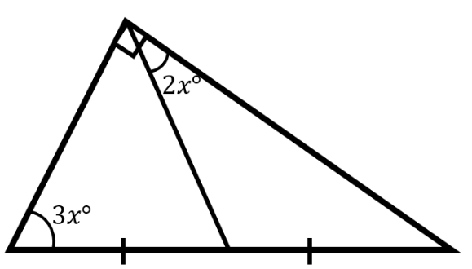
20. (Q-5,2) Rasmda berilgan ma’lumotlardan foydalanib, uchburchakning burchaklari qiymatini toping.
A) $36°, 54°, 90°$
B) $30°, 60°, 90°$
C) $40°,50°, 90°$
D) $24°,36°, 120°$

1. Richakka burchak ostida ta’sir etayotgan F kuchning O tayanchga nisbatan yelkasi quyida berilgan kesmalardan qaysi biri bo‘ladi?
[bilish – 2 ball]
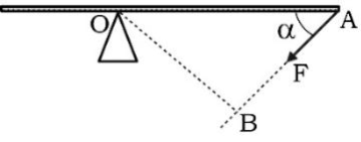

A) OA B) OB C) AB D) 2·OA
2. Ma’lumki, energiyani saqlanadigan (zaxira qilinadigan) va uzatiladigan turlarga bo‘lish mumkin. Quyidagilardan qaysi biri uzatiladigan energiyaga misol bo‘ladi?
[bilish – 2 ball]

A) harakatlanayotgan jismdagi energiya
B) yoqilg‘ida to‘plangan energiya
C) yorug‘lik energiyasi
D) atom yadrosida to‘plangan energiya

3. Jismning shakli o‘zgarganda saqlanadigan energiya qanday nomlanadi?
[bilish – 2 ball]

A) deformatsiya energiyasi (elastik energiya)B) kinetik energiya C) gravitatsion potensial energiya
D) yadro energiyasi

4. Rasmdagi kuchlar ta’sirida jism qanday turdagi deformatsiyaga uchraydi?
[bilish – 2 ball]
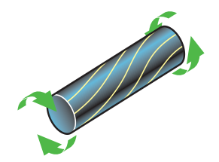
A) buralish B) cho‘zilish C) siqilishD) egilish
5. Rasmdagi vaznsiz richakka 200 N va F kuchlar ta’sir etmoqda. Agar a = 36 cm va b = 45 cm bo‘lsa, tayanchga ta’sir etuvchi reaksiya kuchi qancha bo‘lishini (N) aniqlang.
[qo‘llash – 2,8 ball]
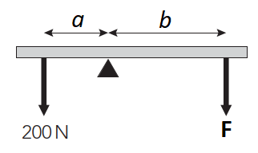
A) 360 B) 160 C) 72 D) 420
6. Rasmdagi bloklar sistemasidan foydalanib, yuk 50 cm ga ko‘tarildi. Bunda ishchi qancha uzunlikdagi (cm) arqonni o‘rab oladi?
[qo‘llash – 2,8 ball]
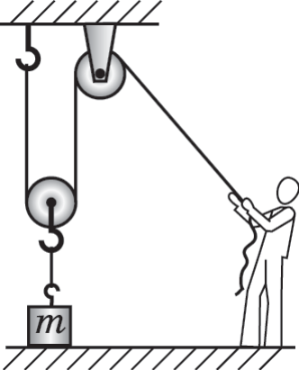
A) 75 B) 50 C) 25 D) 100

7. Massasi 90 kg dan bo‘lgan 6 kishi 4 g‘ildirakli avtomobilga chiqdi. Bunda mashinaning kuzovi 1 cm pastga siljidi. Mashinani g‘ildiraklar ustida ushlab turgan amortizatorlar prujinasining bikrligini (kN/m) hisoblang.
[qo‘llash – 2,8 ball]
A) 540 B) 90 C) 135 D) 180
8. Filning massasi 6500 kg va oyoqlari ostining umumiy yuzasi 0,13 m². Ayol kishining massasi 60 kg va oyoq kiyimlarining umumiy yuzasi esa 25 mm² ga teng. Ulardan qaysi biri polga ko‘p bosim ko‘rsatadi? Necha marta?
[qo‘llash – 2,8 ball]
A) Ayol, 48 marta B) Fil, 48 marta C) Ayol, 96 marta D) Fil, 96 marta
9. Neft saqlanuvchi sisternaning 1,5 m chuqurligidagi bosimni (Pa) hisoblang. Neftning zichligi 980 kg/m³ va g = 10 m/s².
[qo‘llash – 2,8 ball]
A) 9800 B) 13200 C) 15000 D) 14700
10. 3 m uzunlikdagi bir jinsli sterjenning ikki uchidan 20 cm va 40 cm uzunlikda qirqib tashlansa, sterjenning og‘irlik markazi necha cm ga siljiydi?
[qo‘llash – 2,8 ball]
A) 30 B) 20 C) 5 D) 10
11. Prujina cho‘zilishini o‘rganish uchun o‘tkazilgan tajribaning natijalari grafikda ko‘rsatilgan. Grafikda proporsionallik chegarasini toping va shu nuqtaga mos kuch qiymatini aniqlang.
[qo‘llash – 2,8 ball]
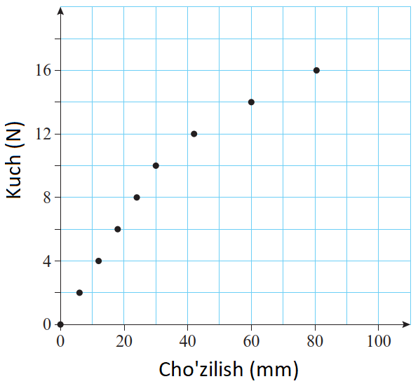
A) 8 B) 12 C) 10 D) 16

12. Richag F₁ = 6 N va F₂ = 18 N kuchlar ta’sirida muvozanatda turibdi. Agar F₁ kuchning yelkasi 15 cm bo‘lsa, F₂ kuchning yelkasi qanchaga (cm) teng?
[qo‘llash – 2,8 ball]
A) 45 B) 10 C) 15 D) 5
13. Avtomobil sekundiga 3·10⁵ J yoqilg‘i energiyasi sarflaydi (kimyoviy energiya). U 1,4·10⁵ J kinetik energiyaga ega va qiyalik bo‘ylab ko‘tarilayotganda bir sekundda 0,8·10⁵ J gravitatsion potensial energiya to‘playdi. Avtomobil sekundiga qancha issiqlik energiyasini (J) ajratib chiqaradi? Erkin tushish tezlanishi g = 10 m/s².
[qo‘llash – 2,8 ball]
A) 2,4·10⁵ B) 8·10⁴ C) 3,6·10⁵ D) 0
14. Massasi 2500 kg bo‘lgan avtomashina 10 m/s tezlik bilan harakatlanmoqda. U tezligi 20 m/s ga yetguncha tezlashdi. Uning kinetik energiyasi qanchaga (kJ) ortadi?
[qo‘llash – 2,8 ball]
A) 125 B) 375 C) 250 D) 500
15. Cho‘g‘lanma lampa uchun Sankey diagrammasi quyidagicha:
[mulohaza – 4 ball]
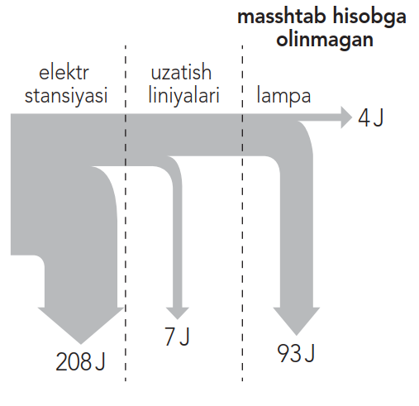

Elektr stansiyasi va uzatish liniyasining foydali ish koeffitsiyentlarini (mos holda) aniqlang.
A) 33% va 93% B) 33% va 67% C) 67% va 7% D) 67% va 93%
1. (2 ball) Which animal is a popular pet?A) rabbit B) lion C) bear D) elephant
2. (2 ball) Complete the sentence with the correct preposition.
Did you turn ___ all the lights before you left?
A) off B) on C) up D) after
3. (2 ball) Choose the right word to complete the sentences.
The __________ was very supportive, so I didn’t feel nervous.
A) audience B) competition C) remote control D) programs
4. (2 ball) Choose the correct answer.
What do you think of this _______ for the main story?
A) headline B) cartoons C) job interview D) advertisement
5. (2.8 ball) Choose the correct answer.
We ___ the match because it started to rain.
A) stopped B) stop C) stops D) stopping
6. (2.8 ball) Choose the correct answer.
We ___ TV at 9 PM last night.
A) were watching B) was watching C) watch D) watched
7. (2.8 ball) Choose the correct answer.
Why ___ they ___ (laugh) while the teacher was giving instructions?

A) were, laughing
B) did, laughed
C) was, laughing
D) are, laughing

8. (2.8 ball) Choose the INCORRECT sentence.
A) He was drove to work when he saw an accident on the road.
B) I was reading a book when the phone rang.
C) They were walking in the park when it started to rain.
D) She was cooking dinner when the lights went out.
9. (2.8 ball) Choose the correct answer.
I ___ (visit) my grandparents this weekend.

A) am going to visit
B) is going to visit
C) are going to visit
D) going to visit
10. (2.8 ball) Choose the correct answer.
She is running very fast. She ___ (win) the race.

A) is going to win
B) are going to win
C) am going to win
D) going to winning

11. (2.8 ball) Choose the correct answer to complete each sentence.
Who ___ she ___ (invite) to the party?

A) is, going to invite
B) are, going to invite
C) am, going to invite
D) is, going to invites

12. (2.8 ball) Choose the correct answer.
_______ visit the museum next week.

A) Let’s
B) Shall
C) Why don’t
D) Will

13. (2.8 ball) Choose the correct answer.
I’m very excited about seeing my uncle again ______ he’s very funny.

A) because
B) so
C) when
D) or

14. (2.8 ball) Choose the CORRECT sentence.
+A) You can take the bus, or you can walk if you prefer.B) We need to hurry and we’ll be late for the movie.C) She loves reading, or she enjoys writing stories too.
D) They brought an umbrella so they thought it might rain.
15. (4 ball) Read the text and answer the question.
Loch Ness
Loch is the Scottish Gaelic word for ‘lake’. Loch Ness is in the north of Scotland not far from Inverness. The loch is 230 m deep – it’s the second deepest loch in Scotland – 36 km long and nearly 3 km wide. There’s more water in Loch Ness than all the water in all the lakes in England and Wales. That’s a lot of water for something to hide in!
The weather around the loch changes quickly. One minute it’s sunny, the next it’s cloudy, the next there’s a bit of rain, and then it’s sunny again. It can be a windy place, too. Clouds move quickly through the sky and on sunny days the clouds make shadows on the water. It’s easy to think you see something in the water. When it’s foggy, the fog sits on the loch and it’s possible to think you see things then too.
The story of the Loch Ness Monster, or ‘Nessie’, started about 1,500 years ago. Then people called it a giant water animal. In the 1930s, a new road beside the loch brought more people to the area and more people started to see more strange things. In fact, over 1,000 people think they saw a strange animal in the loch. There are several photos of some of the strange animals. Could any of them be Nessie?
Why might photos of "strange animals" taken at Loch Ness not be definitive proof of the monster’s existence?
A) Natural elements like shadows and fog could be mistaken for creatures.
B) The photos are too old to be reliable.
C) The loch’s depth makes it impossible to photograph underwater.
D) No credible sources have ever examined the photos.

